38.69: The transition energy equals the sum of the recoiling atom’s kinetic energy and the photon’s energy.
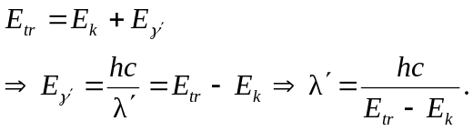
If the recoil is neglected 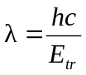
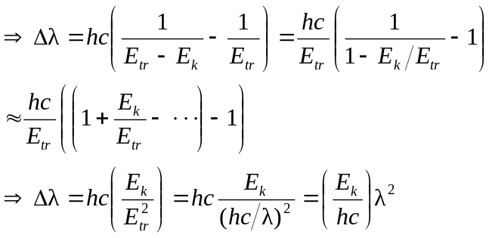
Conservation of momentum, assuming atom initially at rest, yields:
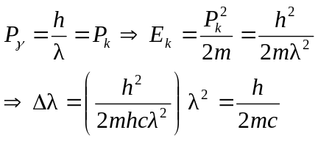
b) For the hydrogen atom: 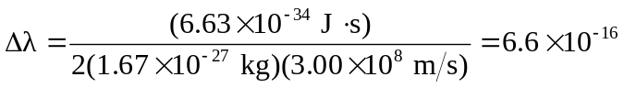 m and it doesn’t depend on

